
Steps for updation of profile for Grades 9 to 12

Step 1 - Click on univariey.com and click on the blue button "login".
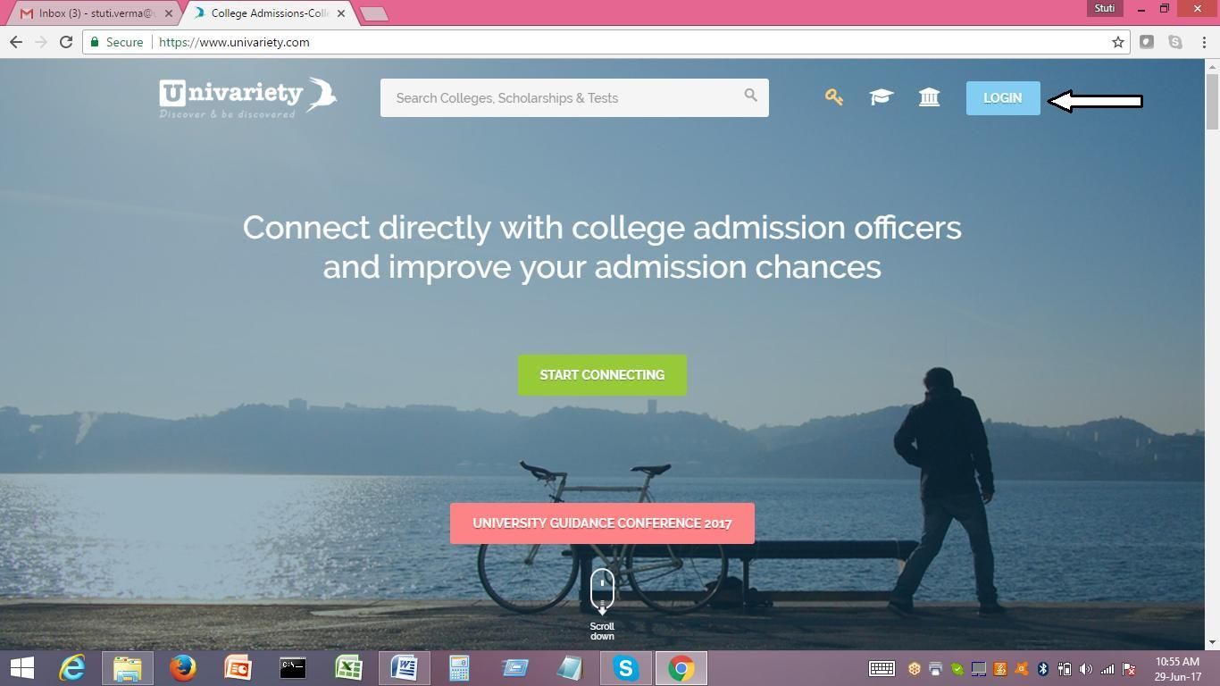

Step 2 - Login to your profile using your Univariety ID and password. The password has been set to a common password - uni123. Your email ID is your Univariety ID and the common password is the password to login.
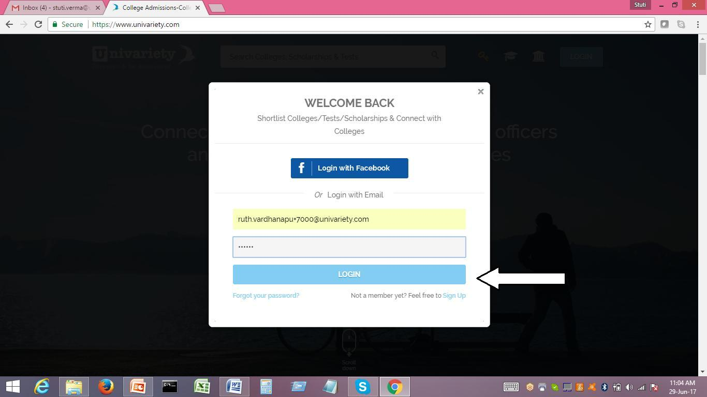

1


Step 3 - You will be directed to the following page. You need to click on the Edit option to update your profile. In case you are directed to the page as visible in diagram (2), please click on the human head as shown and choose the first menu option - Edit Profile. You will be directed to diagram (1)
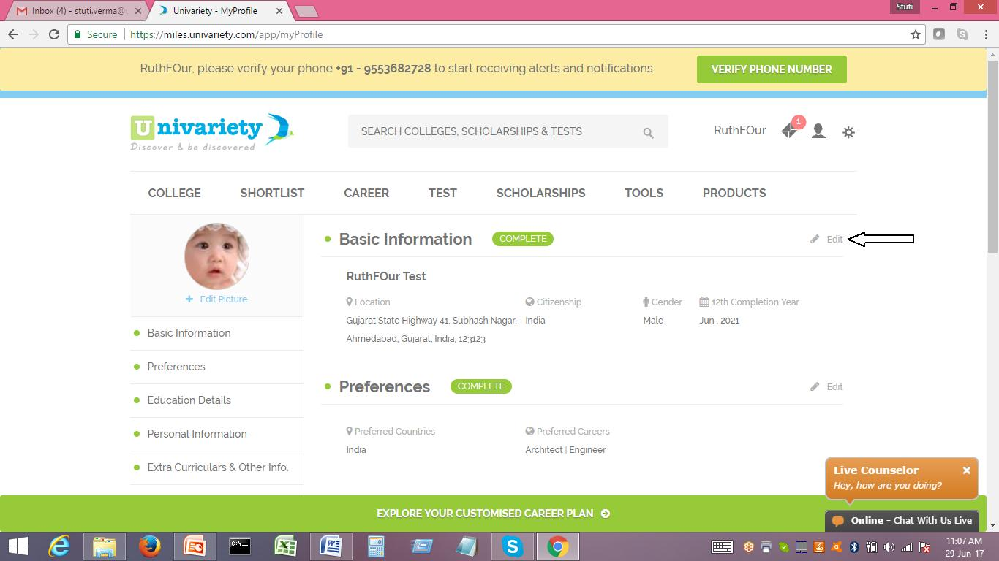

(1)
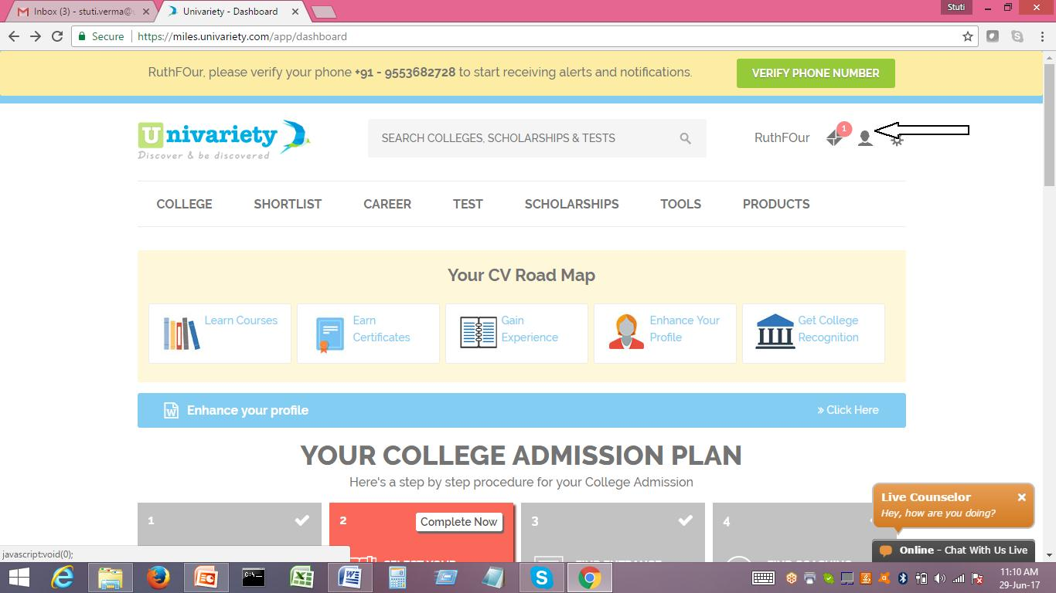

2
(2)

Step 4 - You just need to fill in information in the respective fields and click on Save. Till the time you do not click on Save, your information will not be saved. Please repeat this process for all fields mentioned.
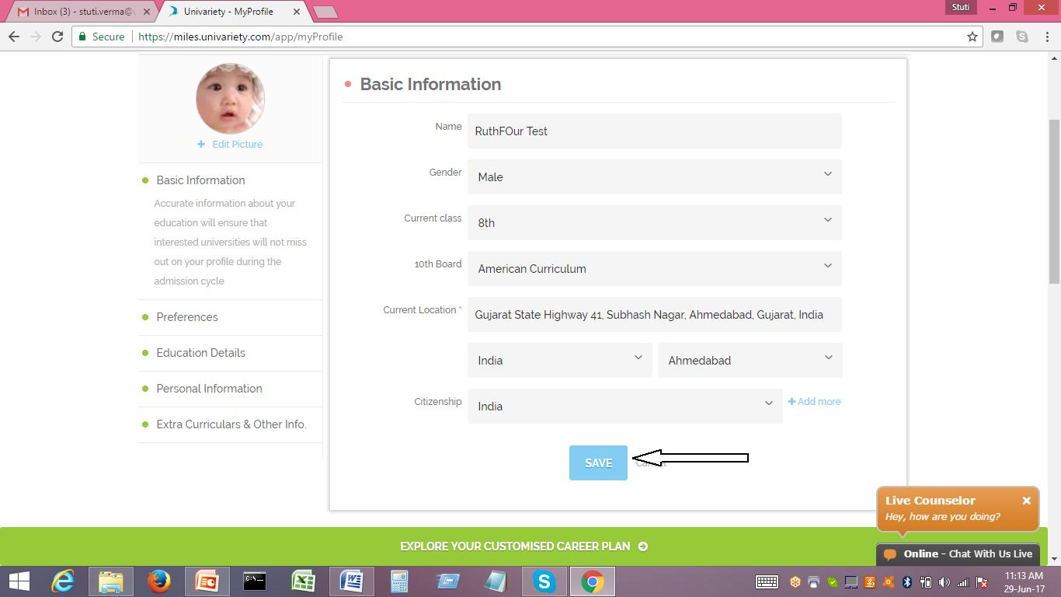

Important Points to note-

- Please fill in details completely and correctly, including your parents' contact details.

- Batch month and year to be filled -

For Grade 9 - May 2021

For Grade 10 - May 2020
For Grade 11 – May 2019
For Grade 12 – May 2018

Therefore, you will be filling in the year in which you will pass out of class 12.

3

