**CORONA's POSITIVE EFFECTS ON LIFE**

**-Raghav Maheshwari**

|  |
| --- |
| [http://2.bp.blogspot.com/-5_cdl_weSzs/XpLGSZ9YVgI/AAAAAAAAAR4/ENqDFTe5VsMLtN4jSbNhd9fo0_5Mv0pXgCK4BGAYYCw/s400/hqdefault.jpg](http://2.bp.blogspot.com/-5_cdl_weSzs/XpLGSZ9YVgI/AAAAAAAAAR4/ENqDFTe5VsMLtN4jSbNhd9fo0_5Mv0pXgCK4BGAYYCw/s1600/hqdefault.jpg) |
| **"WORLD IS CHANGING ,NOW CHANGE YOURSELF"** |

The WORLD in which we are living is undergoing a huge rapid transformation whether it would be technological , physiological or physical. With each single step ahead we are leading towards a more challenging life where all aspects of living are changing , which solely depend on us in which direction we would take that step.

We all have been hearing that a person learns from experiences,mistakes but never worked on that learning , now it is the time when we all should be alert and accept the positive's of each movement and forget about negativity. Today the whole World is fighting against a epidemic (COVID-19) , after few years it would be another epidemic until we change our lifestyle. Each thing has its own pros and cons but its our duty to work and enjoy its opportunities and live every moment with a smile on face.

It is for the first time happening when we can take breathe pure air, can explore sky, experience a better living,where all of us keep quiet and just enjoy that suddenness and understand if we harm the environment that harm will surely come back to us.

[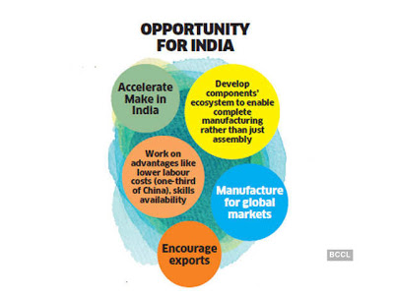](http://1.bp.blogspot.com/-H98-4Bqo-fY/XpLUi-a9ZsI/AAAAAAAAASE/PJzr4XRV0OwpqcMTFQBYrMIPyae5oKHDgCK4BGAYYCw/s1600/5.jpg)

Everything either epidemic or a win comes with lots of opportunities but only thing which it demands is its acceptance and further its execution and even gives lesson which needs to be followed for better transformation such as ***LESS POPULATION*** , LESS POLLUTION , LESS USAGE OF NATURAL & MANMADE RESOURCES . Usage of Anything in excess will lead to its worst result. The best way to grab that opportunities "BE A JOB CREATOR NOT A JOB SEEKER " which automatically solves many problems such as unemployment, enhance economy and GDP which act as boon in difficult situations.

 Another important thing is how you can maintain your immunity so you can fight against severe diseases and leads towards a healthy life. Your Life may be a single life but *If you have life, you have the world.*We need to understand that our hygiene creates a huge difference so we should always take a balanced nutritious diet.

We have got our rivers cleaned , pollution free air,less vehicle on roads so we should keep that same after everything gets normal otherwise it would be even more worst than what we are facing today.

Again I want to mention there is only one way to lead towards great future and even to carry forward the same to future generations is reduce population and education to all.

**STAY HOME, STAY SAFE**

**CHANGE YOURSELF & THEN FEEL CHANGE**