**Parent Login Steps:**

* Download Univariety App-

iOS Users, [Click Here](https://itunes.apple.com/in/app/univariety/id1416689199?mt=8)

Android Users, [Click Here](https://play.google.com/store/apps/details?id=com.univariety.uni)

* Ask your child to Login (Students login credentials shared by Univariety on their email address):

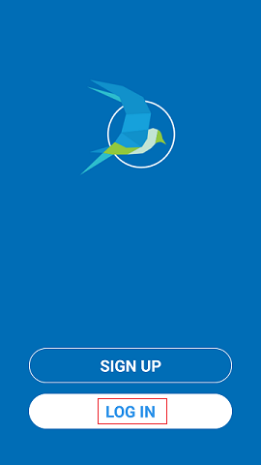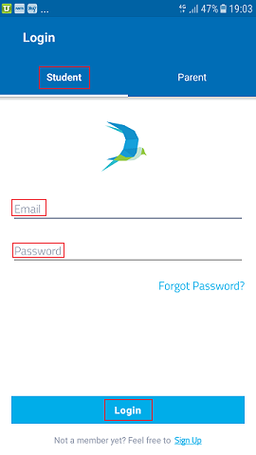

* Click on Menu to see the Parent Code-

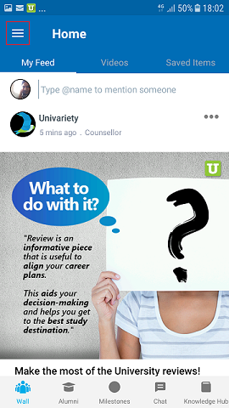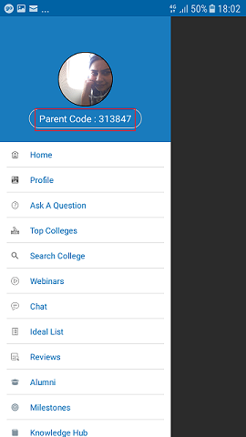

* Use this code to create your Parent Account- Click on **Sign Up**🡪 Choose the option **‘Parent’**

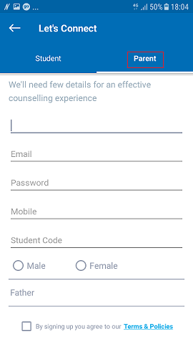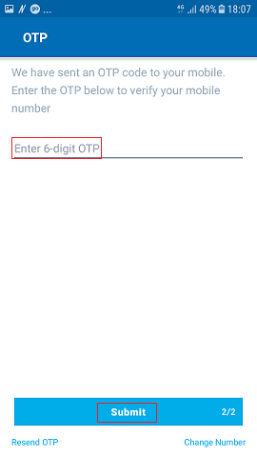

**Note:***In case of any issues, please write to us at* [*planmycareer@univariety.com*](mailto:planmycareer@univariety.com)

Thank You,

Team Univariety