**USA Common Application Personal Essay**

(By Amaan Shariff, +91 9908087861)

Topic:

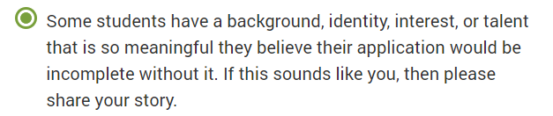

**Essay: Total below is (250 to 650 words)**

I was born in California, USA and moved to India at the age of five due to my father’s job which demanded him to travel all over the world to set up his own software company’s branch offices in Europe and Asia .

Hence, I have been fortunate to receive the best possible education from some of the best educational institutes. I have also been fortunate to be supported by good coaches, talented teachers, kind friends, lovely parents and a wonderful family.

Since my childhood, I have been fascinated with sports. Tennis interested me the most. I started playing and practicing at the age of seven under the guidance of a professional coach who also trained national level players.  I spent 12-14 hours a week, year-round in practicing the sport. At the age of nine, I won the under-10 Singles title at the National level and I was featured in local newspapers. I continued playing various open competitions all over India, conducted by AITA (All India Tennis Association). I won the title in "Under-12 Singles" category at National Level, "Under-14 Singles" and "Under-16 Singles and Doubles" at the State Level. During my high school, I partnered with various players in the Doubles category and won many titles.

Since it requires a great deal of discipline, hard work and focus to win at the national level and state level competitions, these traits are now a part of my personality. I have also taken up mentorship opportunities and have coached Tennis at school level to younger kids, including my younger sister. I would like to continue playing Tennis for college and bring accolades to it, like I did for my school.

Every year, during the month of November, my high school conducts an annual fest called FIESTA as a sendoff to twelfth graders. For 2019, our Principal chose me to LEAD this event. I guess, since I am active in academics, sports, extracurricular activities and was accepted by various groups of students in the earlier events, I was trusted to take up this responsibility. The event was conducted on November 9th, 2019. I strove to display confidence and spent late evenings working with co-organizers to ensure that the event was a grand success.

I also actively participate in annual fund-raising programs for our local orphanage in Hyderabad. This helps me stay grounded and cherish the value of humility.

These experiences have helped me realize that leadership isn't just about having a title - it was a fluid exercise of bringing a team together to transform vision into reality and an innately human desire to be part of something greater. I learned to work with people and empower them to do their best. I hope to inspire people in the same way in college as well.

While discussing my career options with my father who is a co-founder of a software firm which provides solutions based on Artificial Intelligence, I had the opportunity to explore their data science tool called RapidMiner.  This helped me to get insights into areas such as analyzing categorical data, displaying, describing and summarizing quantitative data. I have now decided to pursue Data Science as a major for my undergraduate studies and someday wish to enhance the lives of people through innovative tools that I will create for the same purpose.