Hello Jayitha,

Greetings from Univariety!

Kindly fill in the sections for Ryerson University supplementary form and send with the answers as soon as possible.

**You just have to fill the academic updates, non academic history, Reasons for the choice and Contacts.**

**Academic Admission Requirements**

In order to expedite the review of your application, we are providing you with an opportunity to tell us about your academic achievement(s) in subject prerequisite requirement(s) prior to us receiving your academic transcript(s). View the instructions to determine if you are required to complete this section and for information regarding subject prerequisite requirements.

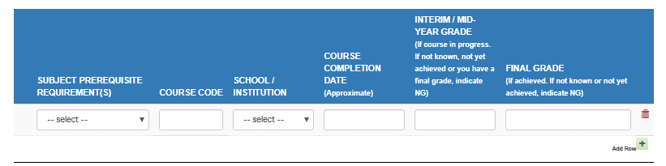

**Self-Reported Grades**

For current secondary school students in Canadian curricula - outside of Ontario and Quebec. View the instructions before completing this section.

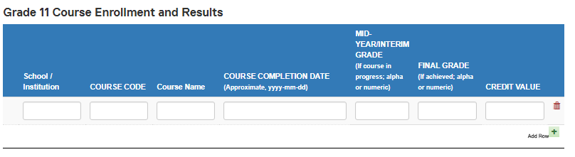

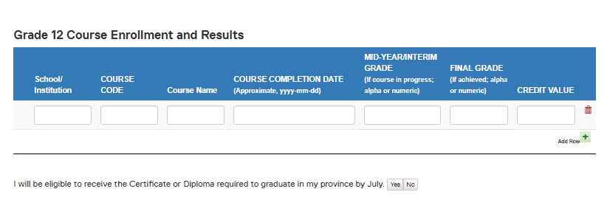

**Academic Update**

Please list any courses you are currently enrolled in or plan to enroll in prior to the academic term you have applied for to ensure that we have complete information when reviewing your qualifications. If you are planning to attend summer school in order to satisfy admission requirements, you must submit a request. Please visit Summer School and Other Extensions.

Note: Please be advised that if you submit this form after a decision has been made this information may not be considered.

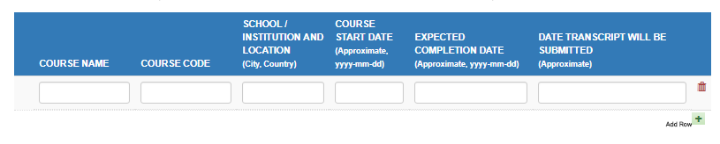

**Non Academic History:**

Please list all non-academic activities, from year to year, from the beginning of secondary school to your expected start date at Ryerson (e.g. employment, volunteer work, travel, etc.). If there are timeframes where you did not participate in any activities and did not attend school, indicate "no activities". It is important to account for your time, in and outside of school.

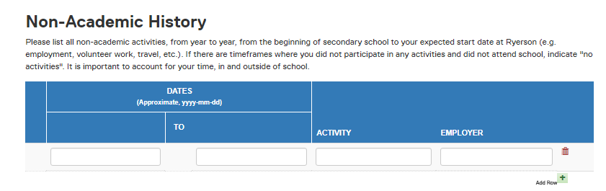

**Reason(s) for Your Choice**

Why do you wish to study this program? What influenced your decision to apply to this program? (max. 4000 characters)

Are there factors that you believe are important/pertinent to the consideration of your application, especially in our review of your academic performance at the secondary and/or post-secondary level? If yes, please explain.

**Contacts**

Please name two people through whom we may reach you and who could verify the information you have provided regarding your academic and non-academic background. At least one contact should be a family member or friend.

