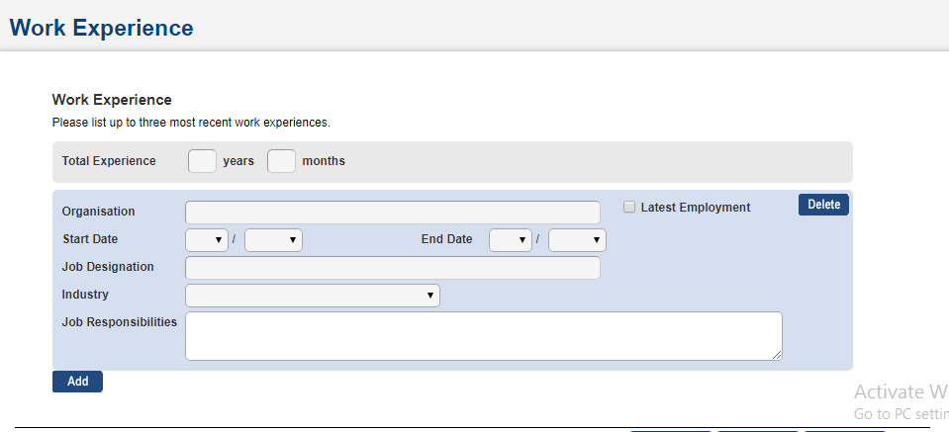

Co curricular Activities Section:

1.Activity:

* Arts and culture
* Clubs and Societies
* Others
* Outside School Activities
* Sports
* Uninformed Groups

2.Year:

3.Description: which should be of 50 words

4.Office Held:

* Captain
* Chairperson/President
* Cordinator
* Director
* Editor in Chief
* Member
* Officer
* Secretary
* Section Leader
* Team Leader
* Treasurer
* Vice Captain
* Vice Chairperson

5.Level of Representation:

* Class
* Others
* School
* State/National

6.Award

**You can add as many as you can**

**Personal Statement: (Max 300 words)**

Describe the highlights of your most outstanding achievements or contributions (Maximum: 300 words). Information that is declared in this section may also be used for selection of admission into SMU under the Discretionary Admissions framework. Examples of such achievements/contributions include but are not limited to the following:

* Excellence and/or leadership in sports and/or arts;
* Impactful leadership and/or participation in community service and volunteer programmes;
* Significant awards and achievements in area/s relevant to the course applied for;
* Noteworthy involvement in work (internship) relevant to the course applied for;
* Noteworthy involvement in entrepreneurial activity;
* Ability to overcome significant difficulties and life challenges.

Talent Groups:

* Arts/Cultural/Musical
* Community Services
* Entrepreneurship
* Grassroots Leadership
* Leadership
* Olympiad Medal Winner
* Others
* Sports

Quick Takes:

1. What would you say is your greatest talent or skill? How have you developed and demonstrated that talent over time? (Maximum 50 words)

2. What have you done to make your school or your community a better place? (Maximum 50 words)

3. What are your future plans or career interests? We are aware that many future plans will change, but this is just another way for us to get to know you as an individual.

Financial Background:

House Hold Income:

Below S$ 500 (Rs. 24,385.69)

Between S$500 to S$999 (Rs.24,385.69-Rs 48,720.56)

Between S$1000 to S$1999(Rs. 48,769.33-Rs. 97,489.89)

Between S$2000 to S$2999 (Rs. 97,533.46-Rs. 146,251.43)

Between S$3000 to S$ 3999 (Rs. 146,300.20-Rs 195,018.4)

Between S$4000 to S$ 4999(Rs. 195,067.18- Rs.195,067.18)

Between S$ 5000 to S$ 5999 (Rs. 243,852.95-Rs. 292,574.77)

Between S$6000 to S$ 6999 (Rs.292,623.54-Rs 341,287.06)

Between S$ 7000 to S$ 7999 (Rs.341,335.82-Rs 390,049.32)

Between S$ 8000 to S$ 8999(Rs 390,115.09-Rs 438,830.71)

Between S$9000 to S$ 9999(Rs. 438,879.48-Rs. 487,595.10)

Over S$ 10000 (Over Rs.487,667.11)