**Parent Information**

**Parent 1/Father/Legal Guardian**

Current Job Category                                  management

Current Job Title director

# of Years 7 years

Previous Job Category                                  middle management

Previous Job Title national sales head

# of Years 17 years

Highest Level of Formal Education                  mba

**Parent 2/Mother/Legal Guardian**

Current Job Category                                  owner

Current Job Title properaitor

# of Years 7 years

Previous Job Category



Previous Job Title



# of Years



Highest Level of Formal Education                  bsc

**---------------------------------------------------------------------------------------------------------------------**

**Family Size & Income**

How many people are in your family?



This Year (2016) 4



Last Year (2015) 4

What is your estimated total household income to support the family size above?

This Year (2016)

$

50 lakhs

.00

Last Year (2015)

$

50 lakhs

.00

**------------------------------------------------------------------------------------------------------------------------------------------------------------**

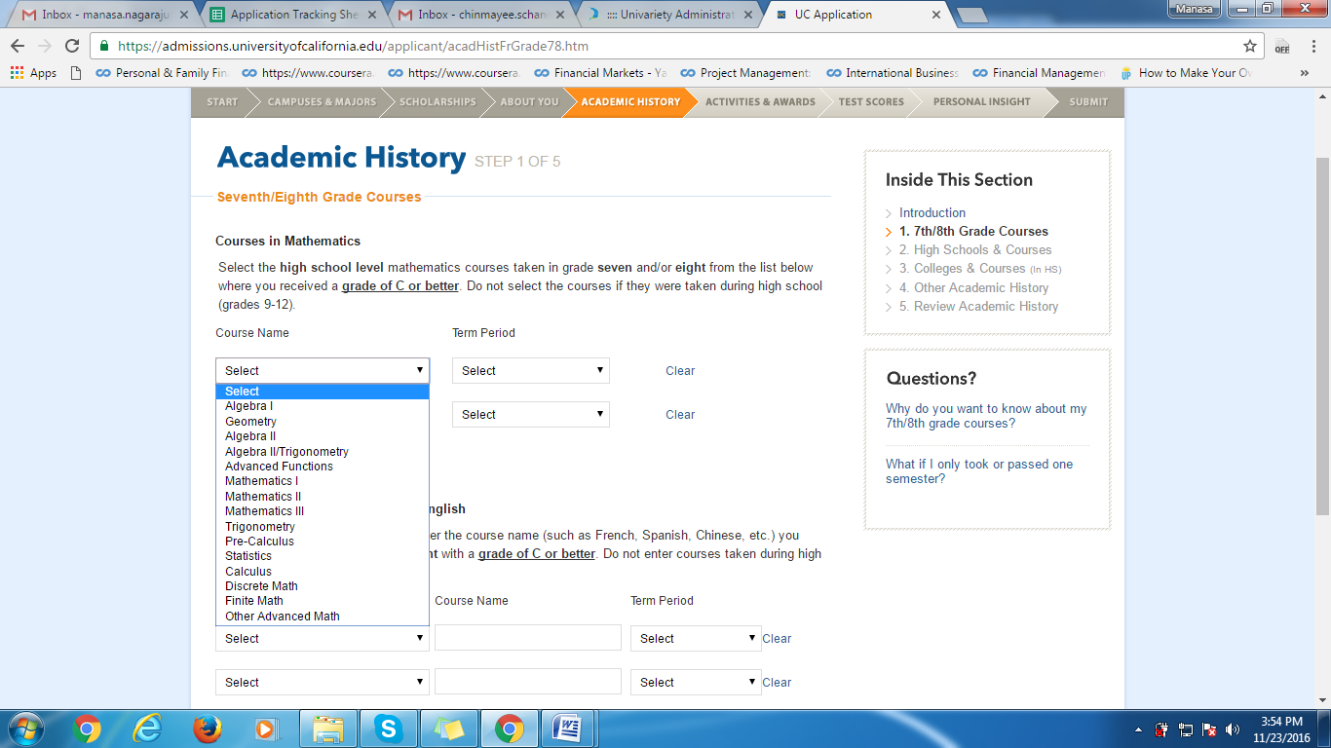

Kindly let me know what topics you have studied in mathematics from the image above and also the grade in which you have studied these topics.

**---algebra ,geomentry, algebra 2, trigonometry, advanced functions, trigonometry, pre-calculus , statistics, calculus------------------------------------------------------------------------------------------------------------------------------------------------------**

### Add Information about HYDERABAD PUBLIC SCHOOL

During what dates did you attend this high school?

Start date:

Month



Year (yyyy)



End date:

Month



Year (yyyy)



What grades did you attend here?

Select the academic year(s) and the grade(s) attended. If you repeated a grade, you must indicate each academic year(s) of attendance for the repeated grade level.

|  |  |  |  |  |  |
| --- | --- | --- | --- | --- | --- |
|  | | | | |  |
| Academic Year | Grade |  |  |  |  |
|  | | | | |  |
|  |  | I took summer courses after this grade. |  |  |  |
|  | | | | |  |
|  |  | I took summer courses after this grade. |  |  |  |
|  | | | | |  |
|  |  | I took summer courses after this grade. |  |  |  |
|  | | | | |  |
|  |  | I took summer courses after this grade. |  |  |  |
|  | | | | |  |
|  | | | | |  |
|  | | | | |  |
|  | | | | |  |
|  | | | | |  |
|  | | | | |  |
| [Add Another Academic Year and Grade](javascript:displayAnotherAcademicYear();) | | |  |  |  |

Is this or will this be the high school you graduated from?

 Yes  No



#### What is your school's grading system?



What is your school's term system?

 Full (1 final grade per year)



 Semester (2 final grades per year)



 Trimester (3 final grades per year)



 Quarter (4 final grades per year)



#### Please choose the language of instruction.



##### **SAT Scores**

##### When did you take this test?

##### SAT with Essay (after Feb. 2016)

When did you take this test?

Month  Year



Section Scores (200-800)

Evidence-Based  
Reading & Writing



Mathematics



**Test scores**

Test Scores

Reading  Writing & Language  Math



------------------------------------------------------------------------------------------------------------------------------------------------------------

|  |  |  |  |  |  |
| --- | --- | --- | --- | --- | --- |
| India Year XII | | | | |  |
| **Grade Scale:** | | | | | |
| **Test Date** | **Subject** | **Score** | **Predicted** | **Not Received** |  |
|  |  |  |  |  | [Clear](javascript:clearFieldsForTestScoreIntlExam(0);) |
|  |  |  |  |  | [Clear](javascript:clearFieldsForTestScoreIntlExam(1);) |
|  |  |  |  |  | [Clear](javascript:clearFieldsForTestScoreIntlExam(2);) |
|  |  |  |  |  | [Clear](javascript:clearFieldsForTestScoreIntlExam(3);) |
|  |  |  |  |  | [Clear](javascript:clearFieldsForTestScoreIntlExam(4);) |
|  |  |  |  |  | [Clear](javascript:clearFieldsForTestScoreIntlExam(5);) |
|  |  |  |  |  | [Clear](javascript:clearFieldsForTestScoreIntlExam(6);) |
|  |  |  |  |  | [Clear](javascript:clearFieldsForTestScoreIntlExam(7);) |
|  | I have not received my scores yet. | |  |  |  |
| [Add Another Subject](javascript:displayAnotherSubject();) |  |  |  |  |  |

Essay Subscores

I have not received my scores yet.

If you plan to take or retake this test, what is the test date?

-------------------------------------------------------------