**Parent Information**

**Parent 1/Father/Legal Guardian**

Current Job Category                                  

Current Job Title

# of Years

Previous Job Category                                  

Previous Job Title

# of Years

Highest Level of Formal Education                  

**Parent 2/Mother/Legal Guardian**

Current Job Category                                  

Current Job Title

# of Years 

Previous Job Category                                  

Previous Job Title

# of Years

Highest Level of Formal Education                  

**---------------------------------------------------------------------------------------------------------------------**

**Family Size & Income**

How many people are in your family?

This Year (2016)

Last Year (2015)

What is your estimated total household income to support the family size above?

This Year (2016)

$



.00

Last Year (2015)

$



.00

**------------------------------------------------------------------------------------------------------------------------------------------------------------**

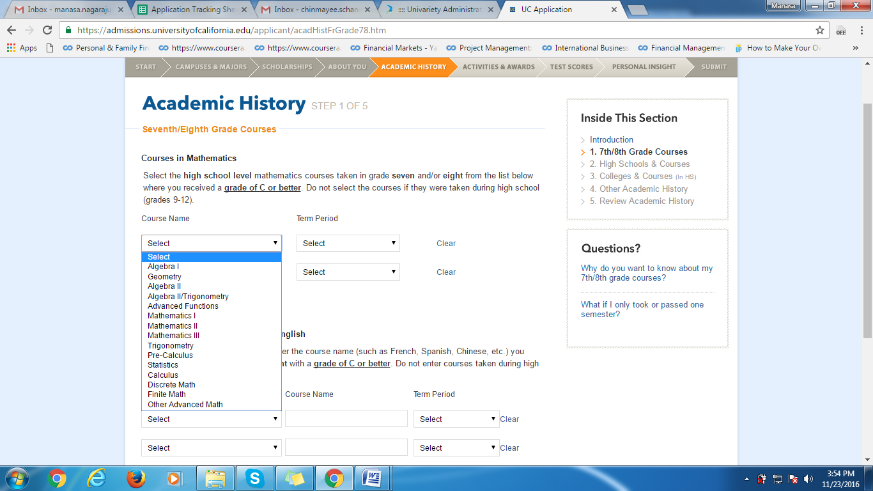

Kindly let me know what topics you have studied in mathematics from the image above and also the grade in which you have studied these topics.

**---------------------------------------------------------------------------------------------------------------------------------------------------------**

### Add Information about HYDERABAD PUBLIC SCHOOL

During what dates did you attend this high school?

Start date:

Month                                 

Year (yyyy)                                 

End date:

Month                                 

Year (yyyy)                                 

What grades did you attend here?

Select the academic year(s) and the grade(s) attended. If you repeated a grade, you must indicate each academic year(s) of attendance for the repeated grade level.

|  |  |  |  |  |  |
| --- | --- | --- | --- | --- | --- |
|  | | | | |  |
| Academic Year | Grade |  |  |  |  |
|  | | | | |  |
|  |  | I took summer courses after this grade. |  |  |  |
|  | | | | |  |
|  |  | I took summer courses after this grade. |  |  |  |
|  | | | | |  |
|  |  | I took summer courses after this grade. |  |  |  |
|  | | | | |  |
|  |  | I took summer courses after this grade. |  |  |  |
|  | | | | |  |
|  | | | | |  |
|  | | | | |  |
|  | | | | |  |
|  | | | | |  |
|  | | | | |  |
| [Add Another Academic Year and Grade](javascript:displayAnotherAcademicYear();) | | |  |  |  |

Is this or will this be the high school you graduated from?

 Yes  No

#### What is your school's grading system?



What is your school's term system?

 Full (1 final grade per year)

 Semester (2 final grades per year)

 Trimester (3 final grades per year)

 Quarter (4 final grades per year)

#### Please choose the language of instruction.



##### **SAT Scores**

##### When did you take this test?

##### SAT with Essay (after Feb. 2016)

When did you take this test?

Month  Year    

Section Scores (200-800)

Evidence-Based  
Reading & Writing

Mathematics

**Test scores**

Test Scores

Reading   Writing & Language   Math  

------------------------------------------------------------------------------------------------------------------------------------------------------------

|  |  |  |  |  |  |
| --- | --- | --- | --- | --- | --- |
| India Year XII | | | | |  |
| **Grade Scale:** | | | | | |
| **Test Date** | **Subject** | **Score** | **Predicted** | **Not Received** |  |
|  |  |  |  |  | [Clear](javascript:clearFieldsForTestScoreIntlExam(0);) |
|  |  |  |  |  | [Clear](javascript:clearFieldsForTestScoreIntlExam(1);) |
|  |  |  |  |  | [Clear](javascript:clearFieldsForTestScoreIntlExam(2);) |
|  |  |  |  |  | [Clear](javascript:clearFieldsForTestScoreIntlExam(3);) |
|  |  |  |  |  | [Clear](javascript:clearFieldsForTestScoreIntlExam(4);) |
|  |  |  |  |  | [Clear](javascript:clearFieldsForTestScoreIntlExam(5);) |
|  |  |  |  |  | [Clear](javascript:clearFieldsForTestScoreIntlExam(6);) |
|  |  |  |  |  | [Clear](javascript:clearFieldsForTestScoreIntlExam(7);) |
|  | I have not received my scores yet. | |  |  |  |
| [Add Another Subject](javascript:displayAnotherSubject();) |  |  |  |  |  |

Essay Subscores

I have not received my scores yet.

If you plan to take or retake this test, what is the test date?

-------------------------------------------------------------