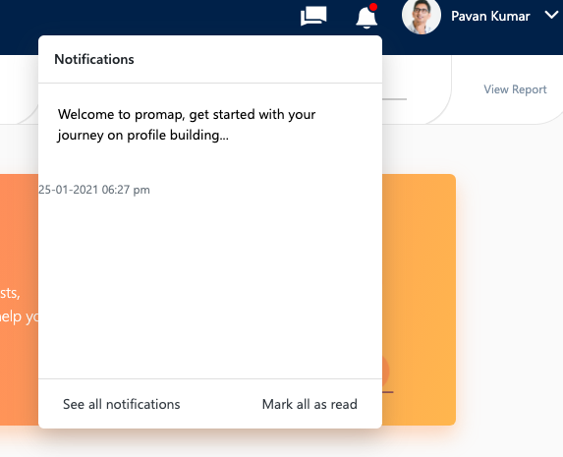
- Notification CSS required- Already update by madhu garu should check once

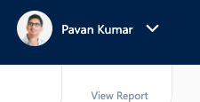
- How and where profile picture will be uploaded(user avatar)


- Link for edit option- Need design Clarification Should discuss this with pavan

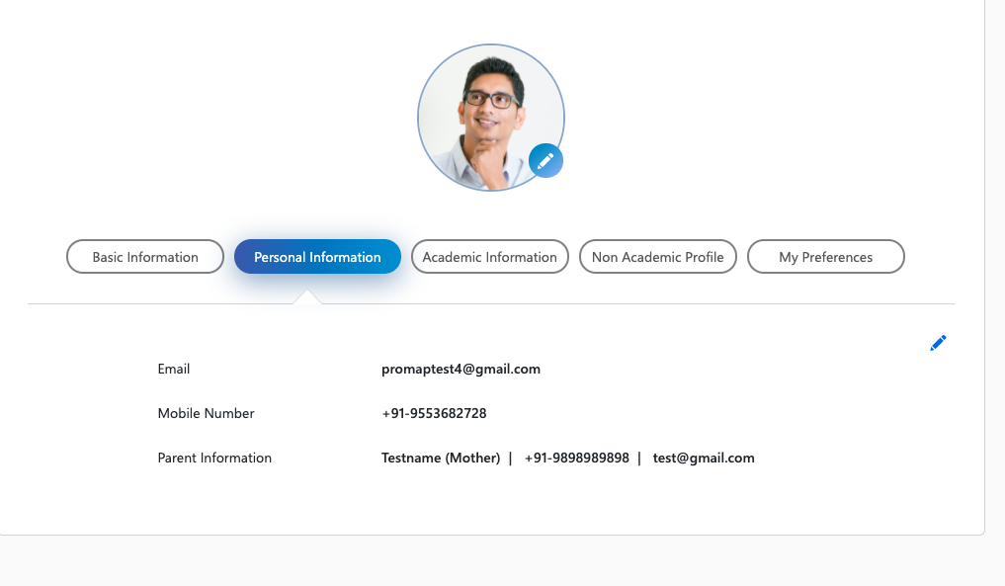
- Edit option link?- Madhu garu will update

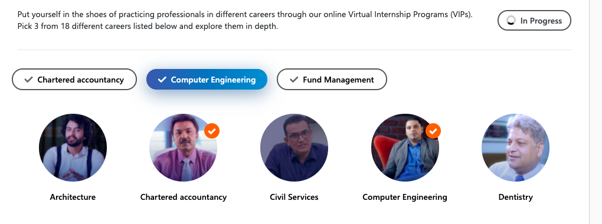

- vip page : in progress icon rotation - they said they will change(madhu)

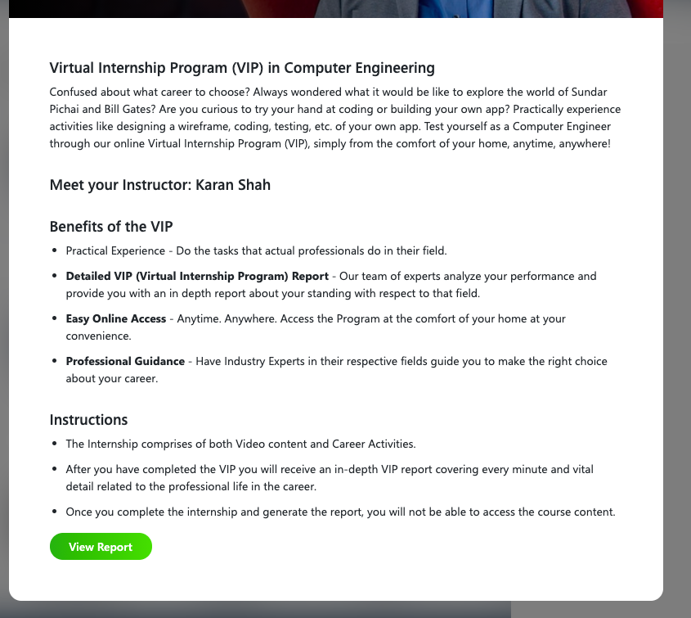
- what should come after clicking view report ( note : they are three VIPs - three have similar report? ) – Should ask pavan
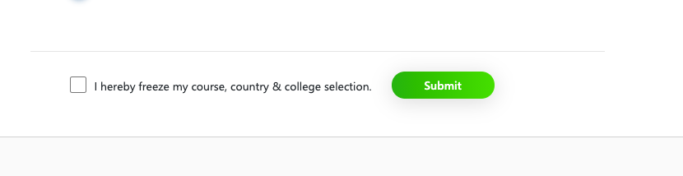
- 3rd milestone: finalise user check box like I agree check box - what error should come if user not clicking check box – Should discuss with pavan

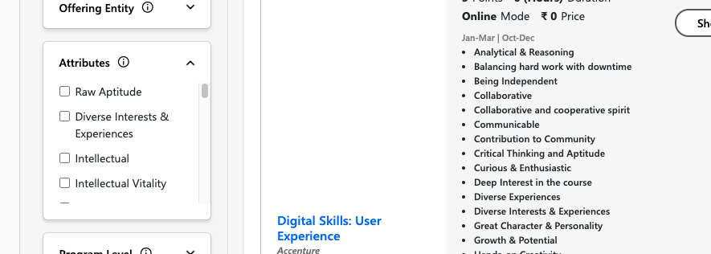
- in road map filters page , programs has too many attributes , whether we show all attributes or not? – Should ask pavan

- see test 3 vip page ( reminder)

