**Company Secretary:**

A company secretary is a senior position in a private sector company or public sector organization, normally in the form of a managerial position or above. The company secretary is responsible for the efficient administration of a company, particularly with regard to ensuring compliance with statutory and regulatory requirements and for ensuring that decisions of the board of directors are implemented.

**Institute of Company Secretaries of India:**

The Institute of Company Secretaries of India (ICSI) is the organization set up under an Act of Parliament, i.e., Company Secretaries Act, 1980, for the regulation and development of the profession of company secretary in India.

As per the provision to Section 203 of the Companies Act 2013 read along with rule 8 and 8A of companies (appointment and remuneration of managerial) rule 2014, all companies having a paid up capital of Rs.5 crore or more are mandatorily required to appoint a full-time company secretary and as per section 204 all listed companies and public companies having a paid up share capital Rs 50 crore or more and turnover of 250 crore or more are required to procure a secretarial audit report from a Practicing Company Secretary which has to be annexed to the Directors' Report along with the annual accounts.

Thus there are two areas in the career: whole-time employment and whole time practice. The Institute, being a pro-active body, focuses on best and top-quality education to students and best quality Set Standards for members.

ICSI has also issued various notes and is also organizing various lectures on Companies Act to make its understanding simpler and easier.

**Why Company Secretary?**

The company secretary ensures that an organization complies with relevant legislation and regulation, and keeps board members informed of their legal responsibilities. Company secretaries are the company’s named representative on legal documents, and it is their responsibility to ensure that the company and its directors operate within the law. It is also their responsibility to register and communicate with shareholders, to ensure that dividends are paid and to maintain company records, such as lists of directors and shareholders, and annual accounts.

**Who should do CS?**

It is generally believed that only students of commerce should pursue CS course. However, CS being a very practical course, the students from science and arts streams can equally benefit and make a successful career. Students of science and arts stream have to make extra efforts in order to understand some complex accounting nuances and have to get basic knowledge of various management topics. But it can be easily concluded that students of science and arts streams can be successful CSs, if they are ready to toil.

If a student has a keen interest in subjects like auditing, taxation, costing, law, and the passion and

dedication towards the profession, he is meant to be in this profession.

**Duration:** The minimum duration of the course is 4.5 years

ADMISSION TO THE CS COURSE is open throughout the year.  Examinations are held twice a year in June & December.

**Registration Procedure**

Students may seek admission to Foundation Programme through online and offline modes. E-Mail Ids and Mobile Numbers are invariably required to be mentioned for prompt response.

(i) Through Online Mode:

Online registration facility is available at Institute’s student portal www.icsi.edu on using the login button on home page. For registration Students are advised to first click on “login” button, then click on “Student” option and then click on “Student Registration”. To apply online, students are advised to read the instructions carefully. The fee can be remitted through Debit/Credit Cards/Net Banking: Once the payment is done, students are advised to upload documents in support of their qualification. Hard copies are not accepted if the student is applying through online mode.

(ii) Through Offline Mode (Physical Submission of the Registration Application Forms at Headquarters, Regional Offices & selected Chapter Offices of the Institute) Student desirous to take admission in CS Foundation Program through off-line mode, is required to submit the prescribed registration form (attached at the end of this prospectus) along with the requisite fee and copy(ies) of the documents i.e. Date of Birth Certificate(10th) and 10+2 Pass Certificate/Mark Sheet (Admit Card/ Hall Ticket in case appearing in the Senior Secondary Examinations) at Headquarters, Regional Offices & selected Chapter Offices. The Headquarters, Regional Councils & selected Chapter Offices issue the Study Materials instantly to the students if the application submitted by them is prima facie in order.

**Stages to become a Company Secretary:**

1. The student who would like to join this CS Course after 10+2 has to undergo three stages to pursue the Company Secretaries Course i.e.

* Foundation Programme
* Executive Programme
* Professional Programme

2. In addition, the student has to undergo Practical Training for about 15 months which a student may opt to start after passing the Executive Programme.

3. The Student who would like to join the Course after passing the Graduation (Example : B.com) has to undergo two stages of the Company Secretaryship i.e.

* Executive Programme
* Professional Programme
* Besides, the student has to undergo Practical Training for about 15 months.

4. Foundation Programme which is of eight months duration can be pursued by 10+2 pass students of Arts, Science or Commerce stream. Excluding Fine Arts.

5. Executive Programme can be pursued by a Graduate of all streams except Fine Arts.

6. Professional Programme can be pursued only after clearing the Executive Programme of CS Course.

7. Training: A Student has to undergo 15 months Management Training in Companies sponsored by the Institute after passing the Executive or Professional Programme or under the guidance of a Company Secretary in Practice.

8. After qualifying Professional Examination and on successful completion of training a candidate is admitted as an Associate Member of the ICSI and can use the letters ACS after his/her name i.e. Associate Company Secretary.

**Graphically representation of process of Company Secretary:**

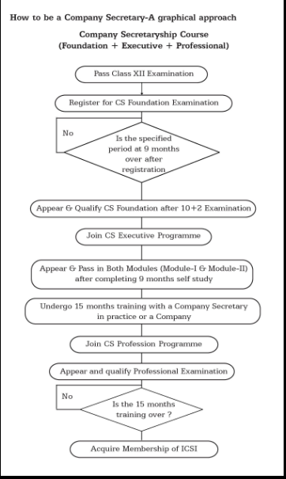

**Company Secretary Foundation level:**

There are 4 subjects in CS Foundation.

* Business Environment and Entrepreneurship
* Business Management Ethics and Communication
* Business Economics
* Fundamental of Accounting and Auditing

CS Foundation Registration is open throughout the year. Candidates registered up to and including the month of March are eligible to take Foundation examination earliest in December in the same year and those registered up to and including September can take up the examination in June next year subject to satisfactory completion of coaching.

**Company Secretary Executive level:**

There are 2 Modules in CS Executive. Module -I contains 4 subjects and Module – II contains 3 subjects.

Module I

* Company Law
* Cost and Management Accounting
* Economic and Commercial Laws
* Tax Laws and Practice

Module II

* Company Accounts and Auditing Practices
* Capital Markets and Securities Laws
* Industrial, Labour and General Laws

Candidates registered as students up to and including May in a year are eligible for appearing in any one Module only of the Executive examination held in December of that year and those registered up to and including the month of November in a year are eligible for appearing in any one Module only in June examination of next year subject to completion of coaching, computer training & other requirements (as per the guidelines of the Institute) in the Module they intend to appear.

**Company Secretary Professional level:**

There are 3 Modules in CS Executive. Module -I contain 3 subjects, Module – II contains 4 subjects and Module 3 contains 2 subjects and 5 elective papers.

Module I

* Advanced Company Law and Practice
* Secretarial Audit, Compliance Management and Due Diligence
* Corporate Restructuring, Valuation and Insolvency

Module II

* Information Technology and Systems Audit
* Financial, Treasury and Forex Management
* Ethics, Governance and Sustainability

Module III

* Advanced Tax Laws and Practice
* Drafting, Appearances and Pleadings

Elective Subjects

* Banking Law and Practice
* Capital, Commodity and Money Market
* Insurance Law and Practice
* Intellectual Property Rights – Law and Practice
* International Business-Laws and Practices

**15 months of Training:**

The students are required to undergo the following trainings:

1. 7 days Student Induction Programme (SIP)- within six months of Registration to Executive Programme or exempted there from for becoming eligible to seek enrolment to appear in Executive Program Examination.

2. 70 hours compulsory computer training program- for becoming eligible to seek enrolment to appear in Executive Program Examination.

3. 8 days Executive Development Programme (EDP) – after passing the Executive Programme and before commencement of 15 months training.

4. 25 hours of Professional Development Programme (PDP) during 15 months training

5. 15 months training after passing the Executive Programme or Professional Programme on completion of Student Induction Program and Executive Development Program with companies and Company Secretaries in Practice registered with the Institute for imparting training

6.3 months practical training is required to be undergone by the student if the student completes professional program examination and exempted from undergoing at least 12 months training on the basis of Company Secretaries Regulations,1982, as amended on submitting the documents to the Institute and fulfills the requirement of Regulation 48. This training will be exempted to the students who have undergone 15 months training.

7. 15 days training in a specialized agency such as Registrar of Companies (ROC) / Stock Exchange / Financial and Banking Institution/Management Consultancy Firm can only be commenced if the student completes SIP,EDP , 15 months training and having passed professional program examination.

8. 15 days Management Skills Orientation Programme (MSOP)- after Professional Programme and on completion of Executive Development Program and 15 months training.

**Fee Structure of CS Course:**

|  |  |
| --- | --- |
| CS Foundation Programme | Rs.4500/- |
| CS Executive Programme | * Rs.9000/- for Commerce Graduates / CPT passed of ICAI / Foundation passed of ICAI-CMA * Rs 10,000/- for Non Commerce Students * Rs 8,500/- for CS Foundation passed students |
| CS Professional Programme | Rs.12,000/- |

**Examination Details:**

1. Examination is conducted twice a year in June and December

2. Examination fee:

Foundation Programme -Rs. 1200/-

Executive Programme - Rs. 1200/- per Module

Professional Programme -Rs. 1200/- per Module

3. Last date for submission of application for appearing in the examination

25th March (with late fee of Rs. 250/- till 9th April)

25th September (with late fee of Rs. 250/- till 10th October)

**Medium of Examination**

The Institute allows facility to students to appear in examination in English as well as in Hindi.

**Qualifying Marks:** A candidate is declared to have passed the Foundation / Executive / Professional examination, if he/she secures at one sitting a minimum of 40% marks in each paper and 50% marks in the aggregate of all subjects.

**Examination Centers in India:**

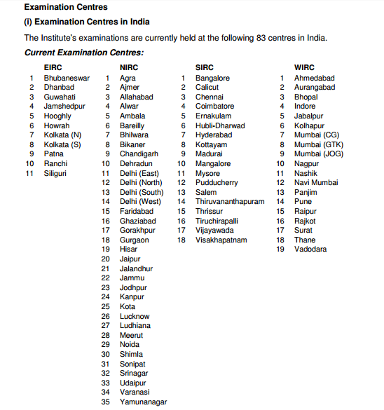

**Membership**

After qualifying the CS Professional Programme and on completion of training as provided under the CS Regulations, a candidate is enrolled as an Associate Member of the Institute and he can use the descriptive title “ACS” after his / her name.

**Job scope**

A qualified CS can either be employed by a company or can start his or her own practice. According to Section 383A, Companies Act 1956, it is mandatory for companies with a paid-up share capital of Rs. 5 crores or more to appoint a CS. Any organisation whose affairs are conducted by boards, councils or other corporate structures; companies seeking listing on stock exchange; central government law services; finance, law, accounts and merchant banking divisions of nationalised banks, as well as public sector companies would employ the services of a CS. “Listed companies, though, rank higher on priority for qualified CS’ looking for a job,” says Ranjit Pandey, a Delhi-based practitioner.

Independent practitioners require a certificate from ICSI (after having qualified as a company secretary). They can then issue compliance certificates to companies (with a paid up share capital between Rs. 10 lakh to Rs. 5 crores) and undertake diligence report for banks etc. They can also be employed by small firms on a retainer ship for professional advice and support on issues such as licenses, registrations, loans, taxes and partnership deeds.

**Levels, Eligibility, Minimum Duration, Maximum duration and Papers:**

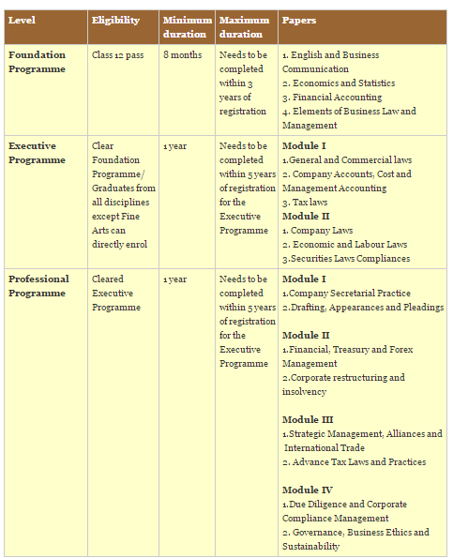

**Role of a Company Secretary:**

Behind Great Corporate Progress there’s a strong backbone: The Company Secretary-

By virtue of integrated knowledge of multiple disciplines of law, management, finance and corporate governance, a Company Secretary is the vital link between the company, its:

– Board of Directors,

– Shareholders,

– Government and other Agencies.

The Company Secretary is:

* An in-house legal expert; a compliance officer of the Company.
* An expert in corporate laws, securities laws & capital market and corporate governance
* Chief advisor to the board of directors on best practices in corporate governance
* Responsible for all regulatory compliances of company
* Corporate planner and strategic manager

**Company Secretaries in Practice also render services in the following areas:**

* Legal, Secretarial and Corporate Governance
* Corporate Restructuring
* Foreign Collaborations and Joint Ventures
* Arbitration and Conciliation
* Financial Management
* Project Planning
* Capital Market and Investor Relations
* Due Diligence
* Corporate Advisory Services.

Reference links

<https://www.icsi.edu/WebModules/AboutUs/Courses/CS_Course_01042014.htm>

<http://www.icsi.edu/student/careerascompanysecretary.aspx>