Medicine in United Kingdom:

Medicine is one of the most competitive courses in the UK. If your grades are of the highest standard, and if you can prove that you have set your heart on studying and working in this field, then applying to read Medicine in the UK is for you. The entry standards for any medical school are strict and exacting. Interviews for admission can be tough and students should expect questioning on motivation, previous work, personal interests, as well as being able to produce evidence of all previous achievements, including relevant work experience.

Medicine in the UK is a five year undergraduate course. Admissions to this course are very competitive and you would require to appear for IELTS and UCAT/ BMAT.

The University Clinical Aptitude Test (UCAT) is an admissions test used by a consortium of UK Universities for their medical and dental degree programmes. The UCAT is a two-hour computer-based test which assess a range of mental abilities identified by university medical and dental schools as important

Online Registration for UCAT will start from 1 of May and closes by second week of September. UCAT testing takes place between 1 July and 2 October . You must complete a two-step process using the Pearson VUE online registration system to register and then book a test. The deadline for applying to UK universities for medicine course is 15th of October

Tests taken outside the EU is £115

UCAT Test Format:

UCAS has the following sections which includes:Verbal Reasoning, Decision Making, Quantitative Reasoning, Abstract Reasoning, Situtational Judgement

<https://www.ucat.ac.uk/ucat/test-format/>

UCAT Accepting Colleges in UK:

Kindly find the list of universities that accepts UCAT: <https://www.ucat.ac.uk/ucat/universities/>

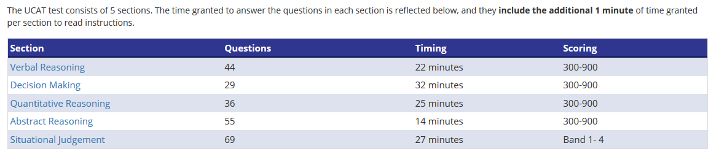

Good UCAT Score:

<https://www.kaptest.co.uk/ucat/info/what-is-good-ucat-score>

**BMAT: BioMedical Admissions Test (BMAT)**

The BioMedical Admissions Test (BMAT) is an admissions test for applicants to Medicine, Biomedical Science and Dentistry courses at certain universities.

BMAT is a 2-hour, pen-and-paper test divided into three sections. You can see what is in each section and also a list of courses that require BMAT below.

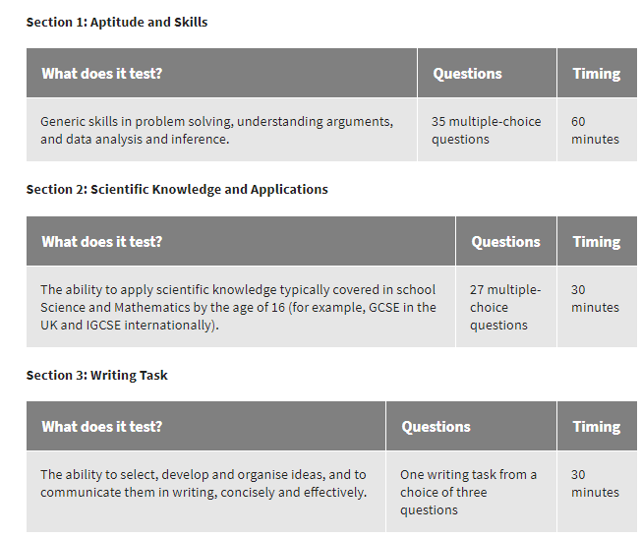

Universities accepting BMAT:

Kindly go through the link for universities accepting BMAT scores:

<https://www.admissionstesting.org/for-test-takers/bmat/bmat-october/>

Registration for BMAT will start from September 1st week and ends in the last week of September

Practice papers for BMAT: <https://www.admissionstesting.org/for-test-takers/bmat/preparing-for-bmat/>

Questions in Sections 1 and 2 are worth 1 mark each. Total raw marks for each section are converted to BMAT's scale, which runs from 1 (low) to 9 (high). Typical BMAT candidates will score around 5.0, roughly half marks. The best candidates will score around 6.0, and a few exceptional candidates will score higher than 7.0.

Section 3 is marked according to two criteria – quality of content (1 to 5) and quality of English (A to E). Here’s a breakdown of the scoring:

Section 3: Written English (scored A, C or E)

Band A: Good use of English – clear, fluent, good use of grammar and vocabulary

Band C: Reasonably clear use of English – reasonably fluent, some errors

Band E: Rather weak use of English – not easy to follow, faulty grammar

Section 3: Quality of Content (scored from 1 to 5)

Score 1: the essay has some bearing on the question but does not address it fully

Score 2: addresses most of the question, but has significant elements of confusion

Score 3: reasonably well-argued, may have weakness in the argument

Score 4: good answer with few weaknesses, all aspects of the question are addressed

Score 5: excellent answer with no significant weaknesses

The two scores for your essay are then averaged to give your final score. So, for instance, if one examiner gave you 2A and another marked your essay 3C, your average score would be 2.5B. If there is a significant discrepancy, your essay will be sent for remarking by a third examiner.