Dear Noor,

Greetings from Univariety

The Personality Test you took is based on the theory propounded by Katharine Cook Briggs and her daughter Isabel Briggs Myers. This test sorts people into 16 different types which are organized by four pairs of opposite traits.

These pairs are:

* Extraversion (E) and Introversion (I)
* Sensing (S) and Intuition (N)
* Thinking (T) and Feeling (F)
* Judging (J) and Perceiving (P)

One of each pair is combined to create a 4-letter abbreviation for each personality type, such as:

ESFP: extraversion (E), sensing (S), feeling (F), perception (P)

INTJ: introversion (I), intuition (N), thinking (T), judgment (J)

These personality traits are grouped into four categories that describe the way in which a person interacts with the world. This is extremely useful in finding out ones’ preferences, interests and abilities. This can lead to a best-fit choice of career that will suit your personality.

Extraversion (E)

Extroverts are energized when in the company of other people, like speaking their minds and thrive in social situations.

Introversion (I)

Introverted people are quiet, reserved, and more comfortable being alone. They are usually self-sufficient and would rather work alone than in a group.

Sensing (S)

Sensing individuals place great emphasis on what they see, touch and experience in the real world. They prioritize facts and practicality, and are outward-looking and prefer not to deal with philosophical ideas or introspective ponderings.

Intuition (N)

Intuitive individuals put emphasis on imagination and ideas, tend to prioritize introspection and dreaming, and oftentimes feel like they do not belong or live in the real world. Intuitive individuals tend to lean towards allusions, read between the lines, and analyze things at greater depth.

Thinking (T)

Thinking individuals are objective, rational, and logical. Their decisions and actions are usually governed more by their minds than by their hearts. They prioritize facts over feelings.

Feeling (F)

Individuals with the Feeling trait care more about emotions and expressing them than what is deemed rational or logical. It only means that those with this trait are more likely to express their emotions.

Judging (J)

Those with the Judging trait tend to strategize and plan before they act. They’d prefer a thought-out plan over going with the flow. They are organized, reliable, and responsible.

Perceiving (P)

People who have the Perceiving trait value their sense of freedom. They do not want to be tied down to a specific activity or commitment if they think there is something better that is worthy of their time. They are good with improvisation, even in emergency situations.

As per the test report, you have an ABCD personality type. This means that the given traits are more dominant in your personality

* Type A
* Type B
* Type C
* Type D

As per the same you are most suitable for the following career options in the given areas:

* Option 1
* Option 2
* Option 3

The above suggestions have been made basis your test report. You must come back on chat to discuss this at length.

Hope this helps you.Do write to us for more.

Cheers!

Saumya Tripathi

Team Univariety

**NOTE FOR CP**: In the section where you have to suggest career options, please DO NOT blankly pick up the first two or three options. The kind of options that are mentioned at the end of the report might not go well with the Indian expectations. Hence you are suggested to mention industries. For ex, have a look at the screen shot below

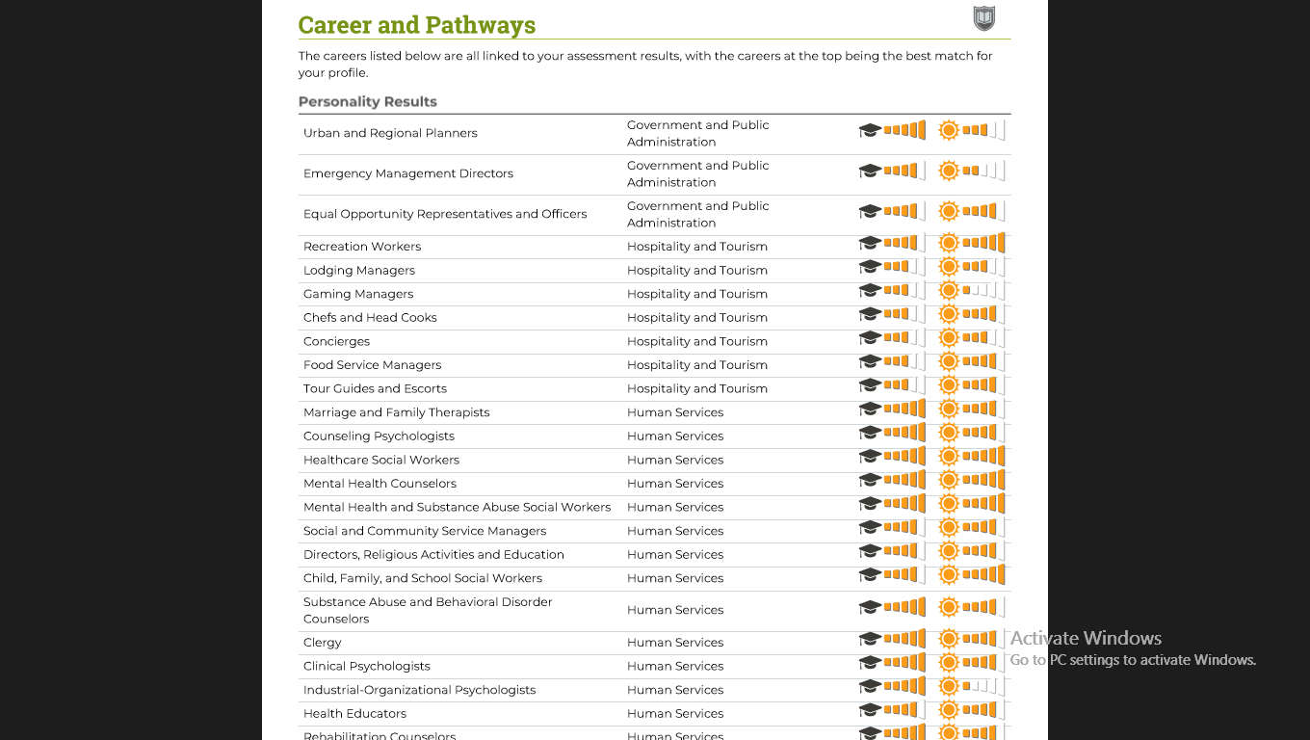

Now for this child you can say

As per the same you are most suitable for the following career options in the given areas:

* Human Resource and Allied Services
* Hospitality and Tourism
* Counselling & Psychology