**Steps to take up the Test on the Univariety Portal.**

Step 1: Once you login to the portal you will be able to see the given below image

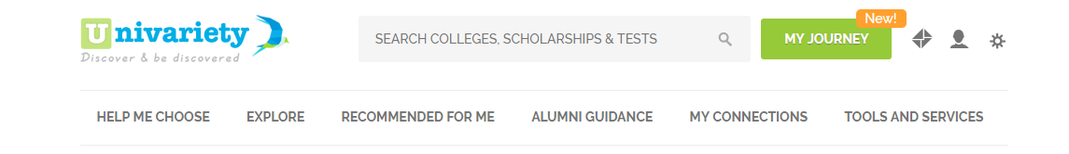

Step 2: You need to click on “Help me choose” tab

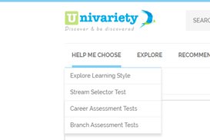

Step 3: Once you click on “Help Me choose”, You will find the different types of test that are are eligible to take. You can click on the test which you wish to take

Step 4: Finally you can take the test.

Step 5:Once you get the report for the test. You can send the test report via Umail.

