**Medicine Admission Guide**

NEET Merit List 2019: The Board releases two types of ranks namely All India Rank (AIR) and All India Quota (AIQ) rank and prepares two merit lists viz. All India merit list and 15% AIQ merit list. The same lists are provided to respective Counseling conducting authorities. The list will carry the names of the candidates having a score more than the minimum qualifying percentile.

**NEET Merit List – Types**

* Merit List of NEET is a rank list having the names of all the qualifiers.
* The names are listed in the order of their ranks.
* The types of merit lists will depend upon the types of ranks allotted to the test taker.

Given in the table below are the types of NEET merit lists 2019 and the types of NEET ranks associated with each.

|  |  |
| --- | --- |
| **NEET Merit List** | **Rank Provided** |
| All India Merit List | All India Rank (AIR) |
| AIQ Merit List | All India Quota (AIQ) Rank |
| States’ Merit Lists | State Rank |

Important Points –

* NEET Merit List will now be used to allot seats in veterinary colleges for undergraduate courses like BVSc. and Animal Husbandry under 15% All India Quota.
* NEET Result will be applicable for admissions to all medical colleges of India except for AIIMS and JIPMER, which conduct their own medical entrance exams.
* Andhra Pradesh and Telangana will now participate in 15% All India Quota Counseling and don’t need to submit a self declaration form anymore.
* For admission into UG courses in AYUSH (Ayurveda, Yoga and Naturopathy, Unani, Siddha, and Homeopathy), students must appear for NEET.

**NEET Admission Process 2019**

Admission will be done in two ways- through All India Quota Counseling and State Counseling.

* 15% of the seats come under the All India Quota.
* Colleges can fill the rest of their seats through state counseling.
* Seats will be allotted according to the candidate’s NEET Score, Rank, colleges chosen during online counseling and cutoff.
* If any seats remain vacant after the two rounds of AIQ Counseling, they will be transferred into State Quota.
* NEET Counseling & Seat Allotment 2019

MCC will declare the number of available seats before each round of NEET Counseling.

* The Counseling is expected to begin in the month of July 2019.
* Centralized Counseling for 15% All India Quota will be conducted by MCC in 2 rounds.
* The state quota admissions will be carried out by respective state Counseling authorities.

**Merit List for 15% All India Quota Seats**

NTA will prepare the merit list for 15 percent All India Quota (AIQ) admissions. Candidates who qualify NEET 2019 by scoring equal to or more marks equivalent to the cutoff of NEET 2019 will be eligible for All India Quota admissions.

* The merit list will have as many names as the number of seats under All India Quota.
* For such candidates, counseling will be done on the basis of their All India Quota Rank.
* There will also be a waiting list equal to 4 times of the merit list or so if required by the DGHS (Director General of Health Services).
* Andhra Pradesh and Telangana will now participate in 15% All India Quota Counseling and do not need to submit a self-declaration form anymore.
* Candidates from J&K still need to produce the self-declaration form for participating in All India Quota Counseling.

**Merit List for seats other than All India Quota**

For the remaining 85% of seats, NTA will give the result to DGHS, to be forwarded to the Admitting authorities.

* An All India Rank will be provided to the candidates.
* Admitting Authorities will invite candidates for Counseling and a separate merit list will be released on the basis of All India Rank.
* State Counseling will be conducted by the respective state Counseling authorities. Candidates must check their websites to stay updated.
* Deemed Universities will conduct their own Counseling procedure.

**NEET State Merit List**

* Other than the two merit lists, respective state counseling authorities prepare their separate NEET 2019 State merit lists.
* These lists are prepared for admissions to state quota seats and MBBS/ BDS seats in private/ self-financing colleges.
* The list will carry the names of all the NEET qualifiers who have registered for participating in the state counseling.
* State merit list of NEET will provide state rank of the candidate which indicate the rank of a candidate amongst all the NEET qualified candidates participating in the state MBBS/BDS counseling.
* Candidates who wish to take admission in AFMC must apply separately on their website since they will hold a second screening process.

**NEET Counseling**

After the declaration of results and cut off, candidates qualifying the exam will be called for the Counseling procedure scheduled in June 2019. They will be issued a call letter, having the information related to Counseling of NEET, schedule, procedure, fee etc. There are various authorities who will hold NEET Counseling. A brief about the same is given below:

**Counseling for 15% All India Quota**

* The Directorate General of Health Services (DGHS), Government of India will hold the Counseling for 15% All India Quota Seats.
* All deemed, central, state universities will participate in online Counseling.
* Seats of ESIC and AFMC, BHU & AMU will also be filled in this Counseling.
* Candidates will apply for 15% All India Quota seats as per the directions of DGHS and Counseling will be stopped soon the seats are exhausted.
* Through this Counseling session, candidates can get enrolled in any college in India.
* Those candidates who take part in All India Counseling can also participate in State Counseling of their respective states.

**Counseling for 85% State Quota Seats**

* For State quota and other seats falling under the ambit of States, candidates may apply to their domicile states and a merit list as per State rules and based on All India Rank will be prepared by concerned Counseling Authorities.
* The Counseling for Private Medical Colleges will also be conducted by the concerned State Counseling Authority.
* Candidates need to register on their concerned state’s Counseling websites.
* Counseling will be conducted on the basis of candidate’s rank in state merit list.
* Admission to colleges in J&K will be done solely on the basis of state Counseling.

**NEET Counseling Registration Steps**

Registration for NEET Counseling begins after the declaration of Result. MCI conducts the Counseling to fill 15% All India Quota Seats in two rounds. The steps involved in NEET Counseling Registration are as follows:

**Step 1:** Visit the official website of MCC and click on ‘New Registration’.

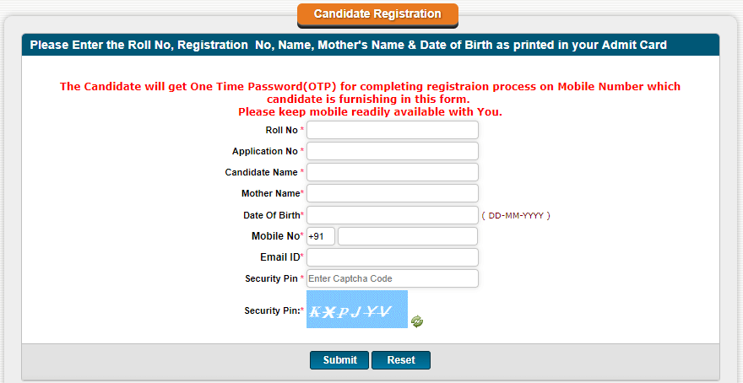

After entering all the required information, a new Roll No. and Password will be generated. Use these credentials to register for NEET Counseling.

**Step 2:** Log on to the MCC website and click on ‘Candidate login’.

**Step 3:** Enter your Roll number and Password.

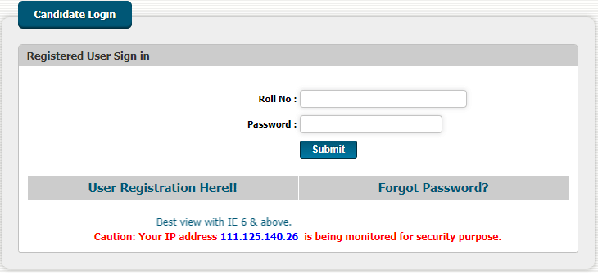

**Step 4:** You will be redirected to a new page where you will have to enter details like Name, Roll No., Registration No., Mother’s Name, Contact No., etc. When you’re done, click on ‘Submit’.

**Step 5:** After this, you will be shown all your details as per the NTA database. Verify the information and click on ‘Confirm Registration’. A Registration Slip will be generated. Candidates are advised to take a printout of this page.

**Choice Availability and Locking**

Choice Locking will be available for a specific time period on a given day.

* Once you’ve registered successfully for NEET 2019 Counseling, click on ‘Choices Available’.
* The system will internally retrieve the candidate’s details like Category, Sub Category, Date of Birth, Eligibility and accordingly shows the choices available for admission along with the number of seats available.
* Choices available will be present on the left side corner and submitted choices will be visible on the right side corner of your screen. Select the medical/dental colleges in the order your preference.
* Once you’re done, enter your password and click on ‘Lock Choices’.
* Candidates are not allowed to make any changes after locking their choices so be very careful in your selection.
* After locking, they can take a printout of the locked choices which will include locking date and time, IP Address of computer and system generated Unique no.

**Documents Required for Counseling**

The following documents will be required during NEET Seat Allotment. Candidates must take original documents along with attested photocopies for admission through 15% All India Quota.

* Admit card
* NEET 2019 Result/Rank Letter
* Birth Certificate
* Class X Certificate
* Class XII Certificate
* Class XII Marksheet
* 8 passport sized photographs (Same as the one affixed on application form)
* Provisional Allotment letter generated online
* Proof of Identity
* Category Certificate (if applicable)

**Top 10 Medical Colleges (as per previous years’ NEET Cutoff)**

* Maulana Azad Medical College, New Delhi
* Bangalore Med. College, Bangalore
* Govt. Medical College, Kottayam
* Government Medical College, Surat
* Seth G.S. Medical College, Mumbai
* Govt. Medical College, Thiruvananthapuram
* IMS BHU, Varanasi, UP
* Lady Hardinge Medical College, New Delhi
* University College of Medical Sciences, Delhi
* Govt. Medical College, Kozhikode

**What if you aren’t able to secure good score at NEET 2019?**

If one isn’t able to secure the desired MBBS seat, one can always reappear for NEET since there are no caps on the number of attempts in NEET anymore. Besides that, candidates should also remember that NEET 2019 score will not only be used for allotting admission to MBBS seats, but also to several other courses including, BDS, BAMS, BHMS, BUMS, BYMS, BSMS and Bachelor of Veterinary Sciences. Given the multitude of options available, candidates can breathe a little easy about what to do after NEET.

One must also remember that the medical domain comprises many different fields which are crucial to the smooth running of the system and can be pursued by one if interested. Courses one can pursue without NEET include Pharmacy, Nursing, Biotechnology, Biomedical Engineering, Forensic Science, Clinical Psychology, Medical Lab Technologist, Optometry, et.al. So worry no more about what after NEET and confidently strive towards attaining your dream medical career.