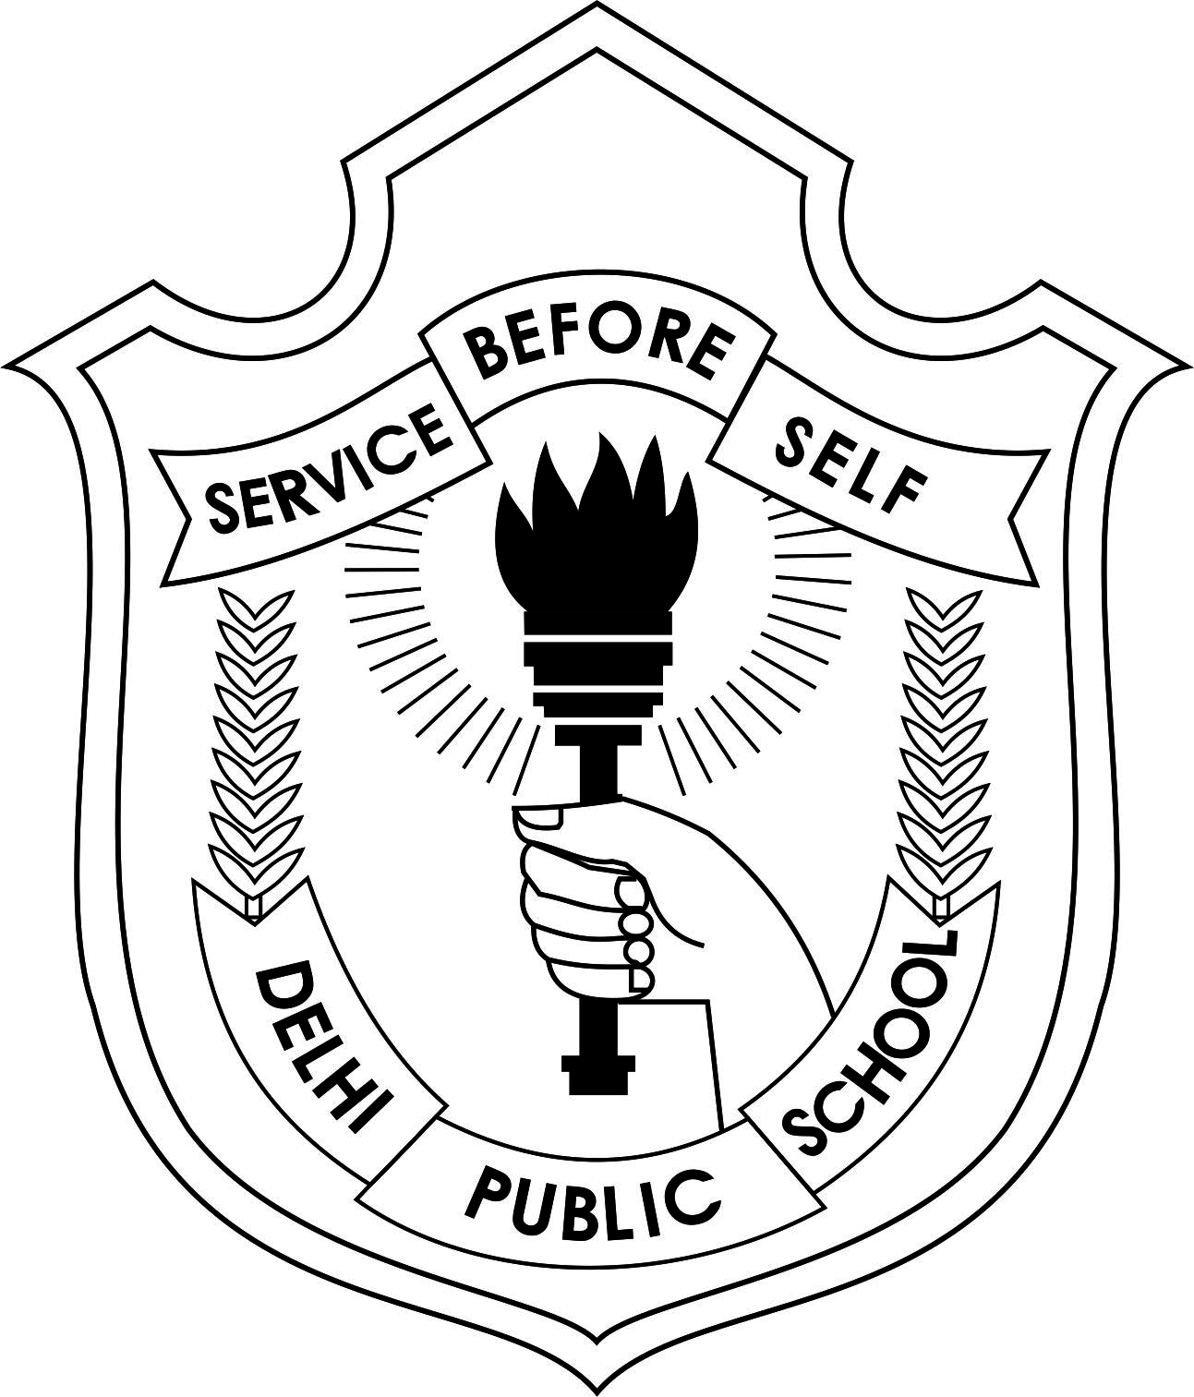

DELHI PUBLIC SCHOOL VARANASI

Invitation for Varanasi Children's Literature Festival

**Dear Dipsite,**

Your school will launch the **first Literary Festival for children in Varanasi**. The Varanasi Children's Literary Festival will launch itself in the orbit on 16th November 2019. To be a two-day event ( 16th & 17th Nov) it will be setup in the school’s sprawling campus. To make the event fruitful and exciting for children and parents of Varanasi, several renowned authors and story tellers will conduct sessions for children. The event will also feature thrilling participatory events for children based on literature.  
On behalf of the entire faculty of the school extend a warm invitation to all the former students to join in this literary sojourn. Your presence I am sure will add joy to the festivity & your peers in the years to come will look up to you for motivation.  
We believe that **VCLF** will become a landmark event in the Varanasi. So mark your calendar, save the date and be the part of it. Please confirm your attendance.   
Your arrival is eagerly awaited.  

**Mukesh Shelat**

**Principal DPS Varanasi**.